**Road-Sync**

(An Android Based App For Smart Route.)



**Bachelor of Science (Computer Science) Session (2021-2025)**

**Submitted by:**

**Aqsa Noor 2123110064**

**Fatima Sarfraz 2123110076**

**Iman Fatima 2123110084**

**Meerab Shahbaz 2123110105**

**Supervisor:**

**Dr. QURA-TUL-AIN KHAN**

DEPARTMENT OF COMPUTER SCIENCE

GOVT. GRADUATE COLLEGE FOR WOMEN SAMANABAD, LAHORE.

AFFILIATED WITH

LAHORE COLLEGE FOR WOMEN UNIVERSITY, LAHORE

**Chapter No 01**

**Introduction**

# 1.1 Overview Statement

Road Sync is an innovative Android application designed to make vehicle tracking easier and more efficient. It uses GPS (Global Positioning System) and GPRS (General Packet Radio Service) technology to provide realtime tracking, making it ideal for fleet management, carpooling, and group travel. The app features a dynamic map interface that allows users to monitor vehicle locations, receive distance notifications, and get traffic alerts. Geo-fencing is another key feature that helps users set virtual boundaries and receive alerts when a vehicle enters or leaves a designated area.

In addition to tracking, Road Sync uses AI-powered route optimization to suggest the best routes based on traffic conditions and travel history. Predictive analytics help users anticipate potential delays, while driver behavior monitoring ensures safer driving practices. The app also prioritizes data security by encrypting location information and ensuring it is only shared with authorized users. With its advanced features and user-friendly interface, Road Sync provides a smart and reliable solution for seamless vehicle tracking and efficient travel management.

# 1.2 Literature Review

## 1.2.1 History and Background

Vehicle tracking systems have improved greatly over time. In the beginning, only big companies used them to keep track of their vehicles. The invention of GPS in the 1980s made tracking more accurate, helping businesses manage their fleets better. Later, in the 2000s, mobile networks and GPRS made real-time tracking possible, making transportation and deliveries more efficient. Today, these systems are widely used by both businesses and individuals to monitor vehicles with ease. With the help of AI and machine learning, modern tracking systems can predict delays, send automatic alerts, and suggest better routes, making travel safer and more convenient.

These advancements also help save fuel, reduce traffic problems, and improve vehicle security, making life easier for everyone.

## 1.2.2 Other Apps

Google Maps

Provides real-time navigation and basic vehicle tracking.

* Waze

Offers live traffic updates and community-driven route suggestions.

* Fleet Complete

A fleet management tool with GPS tracking and basic analytics.

# 1.3 Problem Statement

Real-time vehicle tracking struggles with inaccurate location updates, especially in areas with weak network coverage, causing delays and errors. Managing group travel or fleets is also challenging without features like geofencing, traffic alerts, and emergency notifications for better coordination and safety. Many existing systems lack strong data security, putting user information at risk. Additionally, the absence of AI-driven insights limits smart route planning and real-time decision-making. To solve these issues, a more advanced tracking system is needed with accurate updates, better security, and AI-powered automation for improved efficiency.

# 1.4 Solution

Road Sync solves these challenges by using GPS and GPRS for accurate real-time vehicle tracking. It includes features like geofencing, traffic alerts, and emergency notifications to improve safety and convenience. The app ensures strong data security by encrypting location information and restricting access to authorized users. AIpowered route prediction and driver behavior analysis help optimize routes, improve fleet management, and reduce fuel costs. It also enhances coordination for group travel and fleet operations, making transportation more efficient. With these features, Road Sync offers a smart, secure, and reliable vehicle tracking solution.

These advancements also help save fuel, reduce traffic problems, and improve vehicle security, making life easier for everyone.

## 1.2.2 Other Apps

Google Maps

Provides real-time navigation and basic vehicle tracking.

* Waze

Offers live traffic updates and community-driven route suggestions.

* Fleet Complete

A fleet management tool with GPS tracking and basic analytics.

# 1.3 Problem Statement

Real-time vehicle tracking struggles with inaccurate location updates, especially in areas with weak network coverage, causing delays and errors. Managing group travel or fleets is also challenging without features like geofencing, traffic alerts, and emergency notifications for better coordination and safety. Many existing systems lack strong data security, putting user information at risk. Additionally, the absence of AI-driven insights limits smart route planning and real-time decision-making. To solve these issues, a more advanced tracking system is needed with accurate updates, better security, and AI-powered automation for improved efficiency.

# 1.4 Solution

Road Sync solves these challenges by using GPS and GPRS for accurate real-time vehicle tracking. It includes features like geofencing, traffic alerts, and emergency notifications to improve safety and convenience. The app ensures strong data security by encrypting location information and restricting access to authorized users. AIpowered route prediction and driver behavior analysis help optimize routes, improve fleet management, and reduce fuel costs. It also enhances coordination for group travel and fleet operations, making transportation more efficient. With these features, Road Sync offers a smart, secure, and reliable vehicle tracking solution.

# 1.5 Distinct Features

Road Sync is a smart vehicle tracking solution designed to improve safety, efficiency, and convenience

through real-time updates, AI-powered automation, and strong data security. Below are its key features:

**Real-Time Tracking & Geofencing**

Accurately track vehicles using GPS and GPRS, set up geofencing alerts, and store GPS data offline for later syncing.

**AI-Driven Navigation & Safety**

Get AI-powered route predictions, real-time traffic updates, and an SOS emergency notification feature for added security.

**Driver Monitoring & Fleet Optimization**

Track driving habits, monitor driver performance, and optimize fuel efficiency to enhance fleet management.

**Data Security & Privacy**

Ensure data protection with encryption and privacy controls, allowing only authorized access to location information.

# 1.6 Existing System

## 1.6.1 Problems of Current System

Many existing vehicle tracking systems have limited functionality, lacking advanced features like geofencing and AI-driven route prediction, which are essential for efficient navigation. Poor network connectivity also affects tracking reliability, leading to delays and inaccurate location updates. Additionally, data security remains a major concern, as sensitive location information is often not well-protected, making users vulnerable to data breaches. Another major drawback is the lack of automation, as many systems do not use AI-driven insights to optimize routes and improve decision-making. These limitations make it difficult for users to track vehicles accurately and manage travel efficiently.

## 1.6.2 Suggested Solutions

Road Sync enhances vehicle tracking with advanced features like geofencing, AI-driven route prediction, and emergency notifications, ensuring better safety and efficiency. It also includes an offline mode, allowing users to store GPS data locally and sync it later when connectivity is restored. To protect sensitive location data, the app uses strong encryption and privacy settings, keeping user information secure. Additionally, AI integration helps improve route planning and provides automated alerts, making travel smarter and more convenient. These features work together to create a reliable and efficient tracking solution.

## 1.6.3 Ideas

Road Sync is a smart vehicle tracking solution designed to enhance safety, efficiency, and usability with advanced AI and automation. Below are its key features:

* **AI Integration:** Optimizes routes, monitors driver behavior, and provides real-time traffic alerts.
* **Multi-Language Support:** Allows users to access the app in their preferred language.
* **Emergency Services Integration:** Sends SOS alerts with exact location for quick emergency response.
* **Fleet Maintenance Alerts:** Tracks vehicle health and schedules maintenance to reduce downtime.
* **Enhanced Geofencing:** Creates multiple geo-fences with instant entry and exit alerts.
* **Driver Scorecard:** Evaluates driving habits to improve safety and efficiency.
* **Carbon Footprint Tracking:** Monitors vehicle emissions to promote eco-friendly driving.
* **Customizable Notifications:** Allows users to set alerts based on specific events and preferences.

# 1.7 Motivation

The main motivation behind Road Sync is to create a smart and reliable vehicle tracking system that overcomes the limitations of existing apps. Many tracking systems lack advanced features, so Road Sync includes geofencing, traffic alerts, and emergency notifications to make travel safer and more convenient. It is also designed for group travel, helping users coordinate and stay connected while on the move.

Another important focus is data security, ensuring that users' location information is protected. The integration of AI and machine learning further improves efficiency by providing smart route suggestions and automated tracking, making the system more accurate and user-friendly.

# 1.8 Advantages

* **Real-Time Distance Tracking:** Helps users track vehicle locations accurately, making coordination easier for group travel and fleet management. This feature ensures smooth navigation and better route planning.
* **Geo-fencing:** Allows users to set virtual boundaries and receive alerts when a vehicle enters or exits a specific area, enhancing security and convenience for both personal and commercial use.
* **Traffic Updates:** Provides real-time traffic alerts and AI-driven route predictions to help users avoid congestion, reduce travel time, and optimize fuel efficiency.
* **SOS Functionality:** Enhances safety by enabling users to send emergency alerts with their exact location, ensuring quick response from emergency services or trusted contacts.
* **Offline Mode:** Stores GPS data locally and syncs it once the internet connection is restored, ensuring uninterrupted tracking even in areas with poor network coverage.
* **Data Security:** Uses advanced encryption and privacy settings to protect sensitive location data, ensuring that only authorized users have access to tracking information.
* **AI-Driven Insights:** Utilizes artificial intelligence to analyze travel patterns, predict the best routes, and optimize fleet performance, leading to smarter and more efficient transportation.

# 1.9 Scope

The scope of Road Sync includes developing an Android application that provides real-time vehicle tracking using GPS and GPRS technologies. The app will feature a dynamic map interface, distance notifications, traffic alerts, and geo-fencing capabilities. Initially, the focus will be on Android platforms, with potential expansion to other platforms in the future. The app will require active GPS and mobile network connectivity for real-time tracking, with limited functionality in offline mode. Additionally, future updates will include AI-driven route prediction, fleet maintenance alerts, and expanded security features.

# 1.10 Areas

Road Sync is designed for both businesses and individuals, offering advanced tracking and safety features. It is ideal for fleet management**,** helping companies monitor large fleets, optimize routes, and track vehicle maintenance efficiently. For carpooling**,** the app provides real-time tracking and notifications, making coordination easier and ensuring safer rides. It also improves group travel by allowing users to track multiple vehicles at once, keeping everyone connected and on the right route. Additionally, for personal use, Road Sync offers emergency alerts and geo-fencing, ensuring vehicle security and peace of mind for users.

**Chapter 2**

**Requirement Gathering and Analysis**

# 2.1 Overall Description

Road Sync is a real-time vehicle tracking app that uses GPS and GPRS to offer accurate location updates. It makes fleet management, carpooling, and personal location sharing easier. Users have the ability to track cars, optimise routes, set geo-fences, and send emergency alerts. Secure data flow is ensured by the app's encryption and privacy settings. Road Sync improves collaboration and operational efficiency. It can be used for a number of tracking purposes due to its configurable features. The software places a high premium on user security and data privacy. Its user-friendly interface ensures seamless navigation. Regular updates increase reliability and performance.

## 2.1.1 User Classes and Characteristics

The Road Sync software can be modified to allow for a single user to fulfil the duties of an individual user,a fleet manager, and a carpooling group member. In order to incorporate the capabilities of fleet managers, carpooling groups, and individual users into a single user login for Road Sync, the program should enable users to work as any of these users according to their particular needs.

* Monitor a car or vehicles in real time.
* Get traffic updates and optimise routes for one or more vehicles.
* Let others know where they are.
* Set up geofences and get alerts whenever a car approaches or leaves them.
* In an emergency, send SOS signals.
* Control who can see their location based on their communication history by managing their privacy settings.

### 2.1.1.1 Fleet Manager

Real-time vehicle position monitoring, route management, notifications for unauthorised deviations, and conversation history-based vehicle and driver safety are all necessary for fleet managers. They should be able to track several vehicles at once and produce information on the performance and usage of the vehicles thanks to the system.

### 2.1.1.2 Carpooling Groups

Real-time location sharing, arrival and departure notifications, and simple meeting point coordination are essential for carpooling users. Setting temporary geo-fences and getting notifications when group members arrive at particular locations should be features.

**2.1.1.3 Individual Users**

For safety or coordination reasons, individual users wish to let friends or family know where they are.

## 2.1.2 Operating Environment

Road Sync details are provided to improve comprehension of the operating environment.

### 2.1.2.1 Software Requirements

* **Android OS:** The mobile operating system needed to execute the Road Sync application is specified by the Android OS.
* **GPS and mapping libraries:** These are necessary to track and show the positions of vehicles on a map using the device's GPS capabilities.
* **Real-time database for location data:** This makes it easier to store and synchronise vehicle location data, allowing all authorised users to track and update in real-time. Firebase Realtime Database is one possible example.

### 2.1.2.2 Hardware Requirements

* **Android mobile devices with GPS capability:** Show that in order to guarantee precise location monitoring, Android devices must have GPS funtionality.

* **Mobile network connectivity (GPRS/3G/4G/5G):** This is esential for providing users with real-time updates and for sending location data from the cars to server.

### 2.1.2.3 Network Requirements

**Stable internet connection for real-time data transmission:**

For constant and unbroken data flow which is necessary for real-time tracking, , traffic updates, and

notifications a dependable internet connection is required. Additionally, programs like Canva and Figma can be used to build the user interface (UI).

## 2.1.3 Design and Implementation Constraints

**Some potential challenges and considerations for the Road Sync application include:**

* **GPS Accuracy:** The devices GPS hardware quality, obstruction and weather can all have an impact on location tracking accuracy.
* **Battery Consumption:** using GPS for real-time tracking continously might cause a high rate of battery loss necessitating regular recharge.
* **Network Dependency:** Real-time tracking requires a steady internet connection, and updates may be delayed due to inadequate network coverage.
* **Data Privacy:** only authorized user can access sensitive location data thanks to the applications robust encryption.
* **Real-Time Tracking:** It uses GPSand GPRS technologies to give precise vehicle tracking and distance monitoring for improved coordination.

## 2.1.4 Dependencies and Assumptions

The Road Sync application has the following dependencies and assumptions:

* **User Adoption:** User must enable GPS and allow location permissions for the application to be successful.
* **Third-Party Services:** To display map accurately, the application depends on mapping services like Google Maps.
* **API Availability:** On Android devices the application needs access to dependable network and GPS

API’s.

# 2.2 Feasibility

The Road Sync application demonstrates feasibility across several key areas:

## 2.2.1 Technical Feasibility

For applications based on location, GPS and GPRS technologies are dependable and generally accessible.

Because Android development tools are readily available, developers can create apps more quickly. Firebase and other real-time databases manage location data effectively, guaranteeing seamless synchronisation.

For real-time data management and updating, Firebase Realtime Database is especially helpful.

**2.2.2 Social Feasibility:**

By enhancing safety and cooperation in transportation, the software makes travel safer and more planned. With real-time tracking and improved route planning, it also facilitates fleet management and group travel.

Users can travel more easily, cut down on delays, and check the positions of vehicles.

**2.2.3 Operational Feasibility:**

Operational Feasibility: Companies can implement the application without significantly altering their current configuration because it is made to be readily integrated with fleet management systems. Because of this seamless connectivity, businesses can begin utilising the application without experiencing any operational disruptions. Without the need for extra complicated installations, it aids in increasing productivity, real-time vehicle tracking, and route optimization.

In addition, the application has an intuitive user interface that makes it simple for people of all backgrounds to utilise. The straightforward and user-friendly design guarantees seamless navigation and instant access to crucial elements for any user, be they a fleet manager, driver, or anybody else. A well structured layout, intuitive controls, and clear menus improve the entire user experience and make the program effective and accessible for all users.

**2.2.4 Conomical Feasibility:**

By utilising widely accessible and reasonably priced GPS and GPRS technologies, the application is made to be a cost-effective solution. These technologies provide real-time data sharing and precise position monitoring without the need for costly hardware or intricate infrastructure. The application is an affordable choice because GPS and GPRS are already widely used and may be used by both consumers and enterprises without incurring additional, costly fees.

**2.2.5 Schedule Feasibility:**

The application will be developed using the Agile methodology, which permits flexible and iterative development. Requirement analysis, design, implementation, testing, and deployment are among the lesser stages of development that are guaranteed by this method. The team may continuously enhance the application in response to feedback and changing requirements by adhering to this methodical methodology.

Furthermore, the essential functions may be created and put into use in a fair amount of time. Essential features will be prioritised and made accessible early because the Agile methodology emphasises delivering functional updates in stages, guaranteeing consistent development and a timely project conclusion.

**2.2.6 Logical and Ethical Feasibility:**

By enhancing transportation safety and coordination, the application is intended to deliver a useful service. It helps customers stay informed and travel more securely by providing effective route management and real-time tracking. The app guarantees improved organisation and lowers the chances of misunderstandings or delays, whether it is being used for personal usage, carpooling, or fleet management. The program gives ethical issues top priority, particularly with regard to data security and privacy, in addition to its useful features. It guarantees that only authorised users can access sensitive location data, which is encrypted. Appropriate authorisations and security protocols are in place to guard against misuse and illegal access to personal data. The app fosters trust and guarantees a secure and responsible experience for all users by emphasising user privacy and secure location sharing.

**2.3 External Interface Requirement**

The Road Sync application has the following external interface requirements:

## 2.3.1 User Interface Requirements

* Real-time vehicle tracking requires any easy-to-use map interface.
* Notifcation setting for geo-fences and distance should be adjustable.
* Control for adjusting privacy setting have to be simple to use.

### 2.3.1.1 Android or IOS Application

* **Front-end:** Kotlin
* **Back-end:** Firebase

**2.3.2 Hardware Interface Requirements**

## 2.3.3 Software Interface Requirements

To guarantee accessibility on a variety of smartphones, the application needs to work with Android devices running version 7.0 (Nougat) or later. Because of this compatibility, users can use the app without needing the newest hardware on devices that are still functional but older. Furthermore, a GPS module is required for precise location tracking since it offers the real-time positional information required for the main features of the program. The combination of GPS and GPRS technologies guarantees dependability and user-friendliness due to their widespread availability and proven status. In addition, the application needs GPRS, 3G, 4G, or 5G connectivity to enable smooth data transfer and guarantee that users always receive the most recent information. These connectivity choices improve user experience and performance by enabling the app to operate effectively under various network situations.

|  |  |
| --- | --- |
| **Software’s used** | **Description** |
| Operating system | We have chosen Windows for its best support |
| Database | To Save information we have used Firebase Realtime database |
| Technologies | To implement the project we have chosen kotlin , Firebase. |

**2.3.4 Communication Interface Requirements:**

To provide secure and encrypted data transmission, the system needs secure communication protocols. Push notifications will be used to deliver real-time changes to users. This will improve system dependability and user experience by helping to send critical alerts and status updates immediately.

# 2.4 Functional Requirement

## User Authentication & Account Management

1. **Sign Up**

The sign-up allows users to create an account and access the features of the Road-sync app.

1. **Login In**

The log-in screen allows users to log in to their existing Road-sync app account and access their saved information.

1. **Forget Password**

The "Forget Password" feature allows users to reset their password if they have forgotten it.

1. **Change Password**

Allow registered users to update their passwords to maintain account security.

1. **Edit Profile**

Enable users to manage and update their profile information (e.g., personal details, contactinfo, preference).

1. **Real-Time Vehicle Tracking:**

* Display vehicle locations on a map in real time, updating location data at specified intervals.
* Utilize GPS and GPRS technologies to ensure location accuracy and timely updates.

**7. Route Prediction:**

* Predict optimal routes based on current road conditions and traffic.
* Provide alternative route suggestions, potentially leveraging AI-driven analytics for dynamic traffic alerts.

**8. Geofencing:**

* Allow users to define virtual boundaries (geofences) on the map.
* Automatically send notifications when vehicles enter or exit these predefined areas.

**9. Notification System**

1. Send alerts for a range of events including:
   1. Reaching distance thresholds.
   2. Geofence entry/exit. iii. Emergency situations.
2. Let users customize their notification preferences.

# 2.5 Non-Functional Requirement

## 2.5.1 Performance Requirements

**Real-Time Updates with Minimal Latency**

Even during periods of high utilisation, the system must provide updates for car locations and other dynamic data almost instantly, with a latency of only a few seconds. To guarantee seamless real-time performance, low-latency communication methods (like WebSocket or MQTT) and effective data processing should be employed.

**Efficient Resource Utilization**

In order to guarantee that the program runs effectively on mobile devices and minimise battery drain during continuous operation, optimise CPU, memory, and network use. Use background processing techniques and adjustable refresh rates to strike a balance between power consumption and performance.

**Scalability**

An increasing number of users and cars must be supported by the architecture without noticeably degrading performance. To handle situations with high traffic, load balancing and dynamic resource allocation should be incorporated.

## 2.5.2 Availability Requirements

**24/7 Uptime with Minimal Downtime:**

To guarantee constant availability for consumers with little downtime, the application should aim for a 99.9% uptime. To reduce interruptions, planned maintenance should be announced to users ahead of time and scheduled during off-peak hours.

**Reliable Operation Under Varying Network Conditions:**

By utilising offline modes and data caching techniques, the system must continue to function in settings with limited bandwidth or sporadic connectivity. To bounce back from network outages fast, it is important to provide robust error handling and automatic reconnection functionalities.

**Redundancy and Failover:**

To guarantee service continuity in the case of hardware or software failures, set up redundant systems and backup servers. In order to reduce service interruptions, a disaster recovery strategy ought to be established.

## 2.5.3 Portability Requirements

**Compatibility with Different Android Devices**

In order to guarantee constant performance despite hardware variances, the application needs to be optimised for a broad range of Android devices, from low-end to high-end.

**Support for Multiple Android Versions**

Make sure that all Android versions from a specified minimum (such as Android 6.0 or higher) to the most recent release are compatible, including any fallbacks that are required for legacy systems.

**Adaptability to Various Screen Sizes and Resolutions**

Design a responsive UI that adapts seamlessly to different screen sizes and resolutions, providing an optimal user experience on smartphones, tablets, and other Android devices.

**Modular Deployment**

In order to facilitate quicker updates and cross-platform portability, the application should be structured to support deployment in a variety of contexts with little configuration modifications.

## 2.5.4 Security Requirements

**Secure Data Transmission**

To avoid interception or manipulation, every data transferred between the mobile client and server needs to be secured using strong protocols like TLS/SSL.

**Data Protection and Encryption**

Strong encryption algorithms must be used to hold sensitive user data, such as login credentials and location information. To protect encryption keys, use secure key management procedures.

**Access Control and Authentication**

To limit access to important services and data, use strong authentication techniques like role-based access control (RBAC) and multi-factor authentication (MFA). Review and update security policies frequently to handle new threats.

**Regular Security Audits and Compliance**

To make sure the system stays safe, perform regular penetration testing, vulnerability scans, and security assessments. Verify adherence to best practices and industry standards, including any appropriate certifications.

## 2.5.5 Safety Requirements

**Reliable Emergency Alert System**

A fail-safe method for emergency alerts must be incorporated into the program to guarantee that essential notifications and SOS signals are sent even in the event of unfavourable network conditions. The alert system's redundancy should ensure that emergency signals are promptly received by their intended recipients.

**Accurate Location Data**

For position tracking to remain precise and minimise mistakes even in difficult conditions, high-precision GPS and sensor fusion techniques should be used. To ensure dependability, location data sources must be continuously calibrated and validated.

**Real-Time Monitoring for User Safety**

Incorporate technologies for continuous monitoring that can identify and notify users of performance or accuracy deviations from expectations, guaranteeing prompt action in potentially life-threatening situations. During emergencies, give users precise, doable instructions based on real-time data.

## 2.5.6 Maintenance Requirements

**Ease of Maintenance and Updates:**

Develop the application following clean code standards and modular design concepts, making the codebase easy to maintain, debug, and extend. To make updates and bug fixes more efficient, use version control and continuous integration/continuous deployment (CI/CD) pipelines.

**Modular Architecture:**

Create the system as separate modules or microservices so that modifications may be made to specific areas without affecting the application as a whole.To facilitate rapid troubleshooting and future improvements, each module should have thorough documentation.

**Automated Testing and Monitoring:**

To guarantee system stability and to promptly detect and fix problems, implement through automated testing (unit, integration, and system tests). To enable proactive maintenance, there should be ongoing logging and monitoring to track the performance and health of the application.

**Comprehensive Documentation:**

To facilitate future development and troubleshooting, keep developers' and system administrators' access

to current documentation that covers system architecture, API requirements, and maintenance techniques.

## 2.5.7 Reliability Requirements

**Consistent and Accurate Location Tracking:**

Make sure the system provides regular and accurate location tracking, especially while moving quickly or in places with poor signal strength. To reduce errors and drift, cross-verify location data using redundant sensors and algorithms.

**Minimal Errors and Crashes:**

To lessen the likelihood of software defects, crashes, and unexpected behaviours, the program should undergo extensive testing. In the event of a fault, put in place reliable error handling and logging procedures that enable quick recovery and debugging.

**Robust Load Handling:**

Build the system with scalable architecture to accommodate growing user needs while maintaining good performance and dependability during peak loads. To guarantee system stability under load, performance stress testing must to be carried out on a regular basis.

## 2.5.8 Special Requirements

**Adherence to Data Privacy Regulations**

Assure complete adherence to all applicable laws and data protection requirements, including the CCPA and GDPR. Adopt stringent data minimisation procedures, gathering only the data required to run the program.

**Transparency and User Consent:**

Clearly and easily communicate regulations about data collection, use, and storage. Obtain express user consent before processing data and provide simple ways to control privacy settings.

**Anonymization and Data Minimization**

Anonymise user data whenever you can to preserve privacy without compromising service operation.

Retain only the information required for operations, and make sure that outdated data is regularly purged.

**Auditing and Reporting**

To guarantee accountability and adherence to legal obligations, keep thorough logs and audit trails of all data access and alterations. Allow for recurring evaluations and reporting systems to keep an eye on compliance with data security and privacy regulations.

**Chapter No 03**

**Design**

# 3.5 Collaboration Diagram

### 3.5.1 Sign up

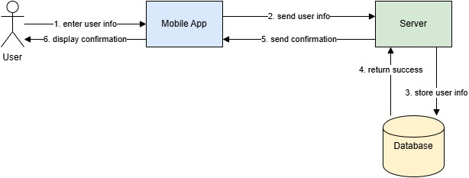

**Figure 3.6 Sign Up**

### 3.5.2 Sign in

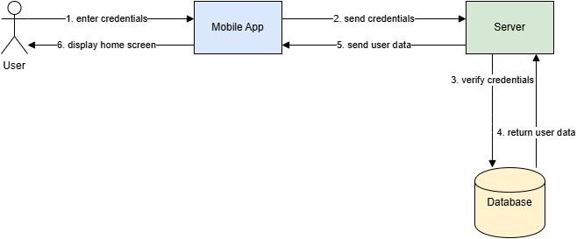

**Figure 3.7 Sign I**

### 3.5.3 Forget Password

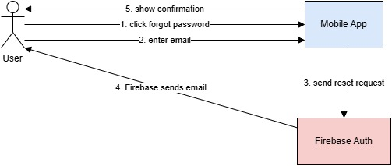

### 

**Figure 3.8 Forget Password**

### 3.5.4 Change Profile Image

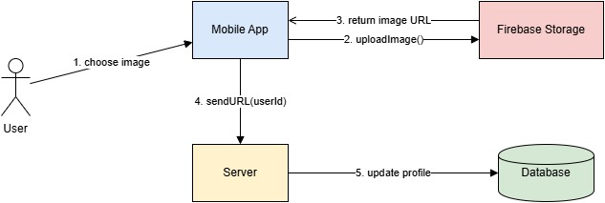

**Figure 3.9 Change Profile Image**

### 3.5.5 Save Emergency Contact

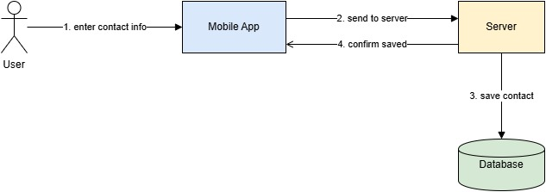

**Figure 3.10 Save Emergency Contact**

### 3.5.6 Create Trip

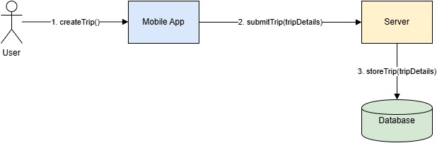

**Figure 3.11 Create Trip**

### 3.5.7 Invite Participants/Members

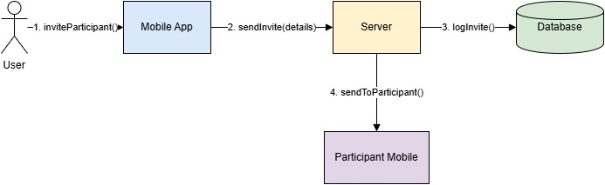

**Figure 3.12 Invite Participants**

### 3.5.8 Send Notification

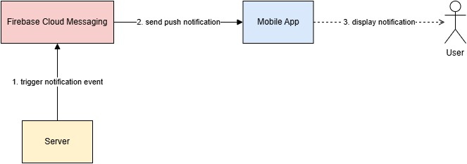

**Figure 3.13 Send Notification**

### 3.5.9 Start Trip

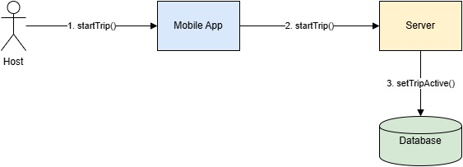

**Figure 3.14 Start Trip**

### 3.5.10 Join Trip

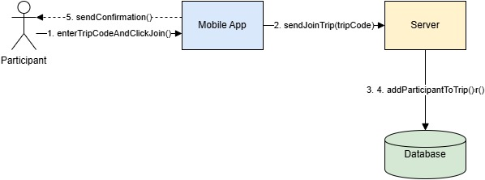

**Figure 3.15 Join Trip**

### 3.5.11 Location Tracking

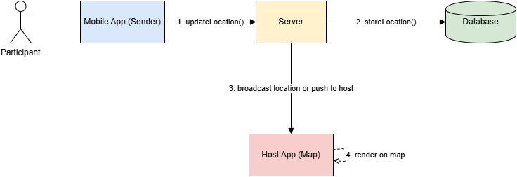

**Figure 3.16 Location tracking**

### 3.5.12 Add Trip Cost

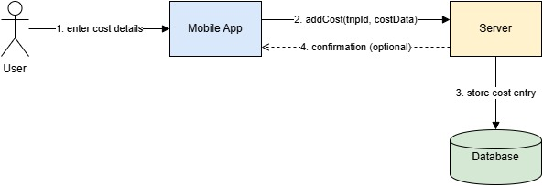

**Figure 3.17 Trip Cost**

3.5.13 Add Trip Image

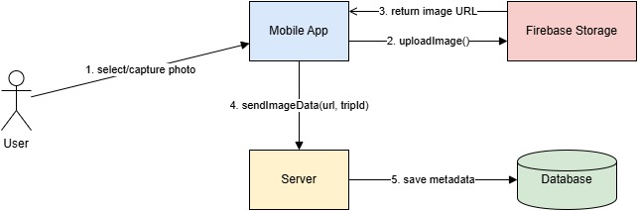

**Figure 3.18 Trip Image**

### 3.5.14 Show Trip Image

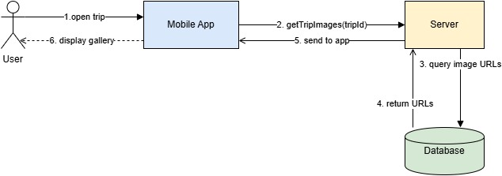

**Figure 3.19 Show Trip Image**

### 3.5.15 Remove Users

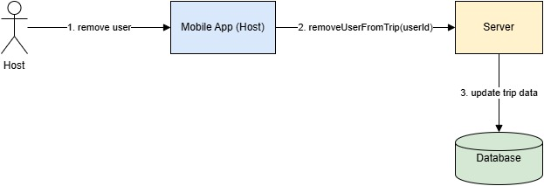

**Figure 3.20 Remove User**

### 3.5.16 Geofence

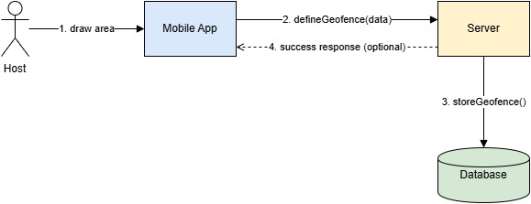

**Figure 3.21 Define Geofence**

### 3.5.17 Send Alert

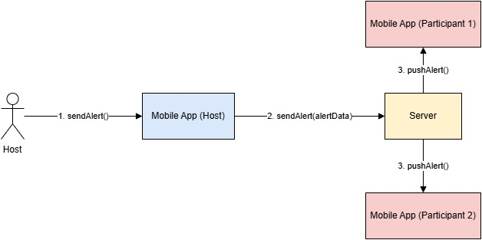

**Figure 3.22 Send Alert**

### 3.5.18 Users

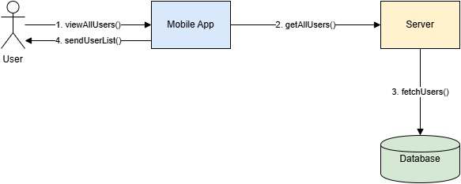

**Figure 3.23 User List**

### 3.5.19 Show Trip

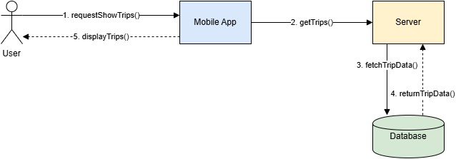

**Figure 3.24 Show Trip**

### 3.5.20 End Trip

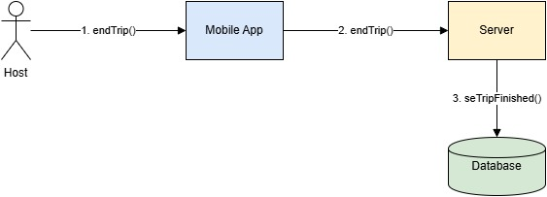

**Figure 3.25 End Trip**

### 3.5.21 All Trips

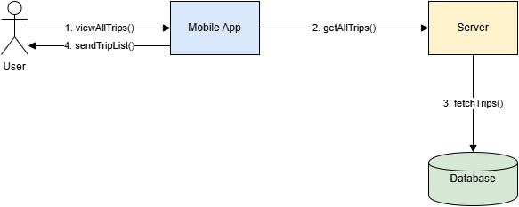

**Figure 3.26 All Trips**

### 3.6 System Level Use Case

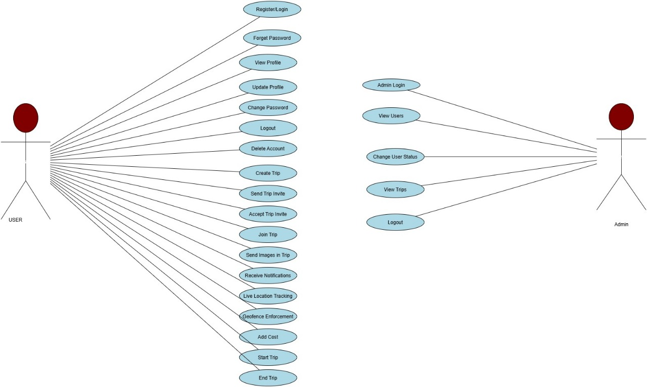

**Figure 3.27 System Level Use Case**

### 3.6.1 Sign up (U1)

1. **U1**
2. **Objective** – This feature allows users to create a new account by entering required personal information.
3. **Priority** – High
4. **Source** – All inputs are provided by users.
5. **Actors** – User
6. **Flow of Events** 
   1. **Basic Flow** 
      1. Users opens the registration screen .
      2. Users fills the requied information.
      3. Application Validates and saves the user’s data.
      4. User account is created..
   2. **Alternate Flow(s)** – Information is invalid.
      1. An error message is displayed telling the Users that don’t provide right information.
      2. User is prompted to re-enter data.
7. **Includes** – None
8. **Preconditions** – A user must not have an existing account.
9. **Post condition** –A Users account is created and they will be able to access all functionalities provided by the Application.

### 3.6.2 Sign-In (U2)

1. **U2**
2. **Objective** –This feature allows the Users to sign in to his account using his email and password .
3. **Priority** – High
4. **Source** – All inputs are provided by users.
5. **Actors** – User
6. **Flow of Events** 
   1. **Basic Flow** 
      1. Users enters username and password. .
      2. The Application verifies the credentials.
      3. App granted access to user.
   2. **Alternate Flow(s)** – Invalid credentials.
      1. An error message is displayed telling the users they provide inaccurate information.
      2. Return to step 6.1.1.
7. **Includes** – None
8. **Preconditions** – A Users account is created and they are able to access all functionalities provided by the App.
9. **Post condition** – Users is logged in to App.

### 3.6.3 Forget Password (U3)

1. **U3**
2. **Objective** – This feature allows users to reset his account password.
3. **Priority** – Medium
4. **Source** – All inputs are provided by users.
5. **Actors** – User
6. **Flow of Events** 
   1. **Basic Flow** 
      1. User opens the app.
      2. Displays forgot screen.
      3. User enter the email for reset the password.
      4. App validates the given information.
      5. User reset his new password.
      6. Password sent to the required email address.
   2. **Alternate Flow(s)** – At 6.1.3 Password is not reset if the user is not registered.
      1. An error message is displayed telling the user you are not registered.
      2. Return to step 6.1.2.
7. **Includes** – UI
8. **Preconditions** – User must be logged in and have a good internet connection.
9. **Post condition** –User successfully resets his password.

### 3.6.4 Change Profile Image (U4)

1. **U4**
2. **Objective** – This feature allows enable users to changes their profile picture.
3. **Priority** – Low
4. **Source** – All inputs are provided by users.
5. **Actors** – User
6. **Flow of Events** 
   1. **Basic Flow** 
      1. User navigates to profile settings.
      2. User select new image.
      3. Image is uploaded and saved.
7. **Includes** – None
8. **Preconditions** – User is logged in.
9. **Post condition** – Profile image is uploaded..

### 3.6.5 ****Save Emergency Contact**** (U5)

1. **U5**
2. **Objective** – This feature allows users to add and save emergency contact in the app.
3. **Priority** – High
4. **Source** – All inputs are provided by users.
5. **Actors** – User
6. **Flow of Events** 
   1. **Basic Flow** 
      1. User navigates to the Emergency Contact section.
      2. User enter the contact number.
      3. Application validates the input.
      4. Application saves the emergency contact.
   2. **Alternate Flow(s)** –Missing or invalid input.
      1. An error message is displayed (Phone is invalid).
      2. .The user is prompted to correctly re-enter the contact no.
7. **Includes** – None
8. **Preconditions** – User must be logged in.
9. **Post condition** – Emergency contact is saved and ready to be used in alerts.

### 3.6.6 Create Trip (U6)

1. **U6**
2. **Objective** – . This feature allows users to create a new trip by entering trip details such ast rip name, destination,stay,cost etc.
3. **Priority** – High
4. **Source** – All inputs are provided by users.
5. **Actors** – User
6. **Flow of Events** 
   1. **Basic Flow** 
      1. User navigates to the “Create Trip” option.
      2. User fills in trip details.
      3. Application validates the details.
      4. Trip is created and stored in the database.
   2. **Alternate Flow(s)** – Incomplete or incorrect details..
      1. An error message is displayed.
      2. User is prompted to correct the input.
7. **Includes** – None
8. **Preconditions** – User must be logged in
9. **Post condition –** Trip is created and appear in the trip list.

### 3.6.7 Invite Participants (U7)

1. **U7**
2. **Objective** – Allows users to invite other members to join a specific trip.
3. **Priority** – High
4. **Source** – All inputs are provided by users.
5. **Actors** – User
6. **Flow of Events** 
   1. **Basic Flow** 
      1. User selects a trip.
      2. User choose participants to invite.
      3. Invitation is sent.
   2. **Alternate Flow(s)** – No user selected
      1. An error message is displayed.
      2. Please select at least one participate.
      3. Return 6.1.2
7. **Includes** – None
8. **Preconditions** – Trip must be created.
9. **Post condition –** Invitations are successfully sent.

### 3.6.8 Send Notification (U8)

1. **U8**
2. **Objective** –
3. **Priority** –
4. **Source** –
5. **Actors** –
6. **Flow of Events** 
   1. **Basic Flow**
   2. **Alternate Flow(s)** –
7. **Includes** –
8. **Preconditions** –
9. **Post condition –**

### 3.6.9 Start Trip (U9)

1. **U9**
2. **Objective** – Starts an ongoing trip and begins tracking.
3. **Priority** – High
4. **Source** – All inputs are provided by users
5. **Actors** – User
6. **Flow of Events** 
   1. **Basic Flow** 
      1. User selects a planned trip.
      2. User click the “Start Trip” .
      3. System updates trip status.
   2. **Alternate Flow(s)** – No trip selected
      1. If the user doesn’t click the start button trip will not start.
      2. The app does nothing untill the user starts the trip manually
7. **Includes** – None
8. **Preconditions** – Trip must be created.
9. **Post condition –**  Trip is marked as “in progress”.

### 3.6.10 Join Trip (U10)

1. **U10**
2. **Objective** – This features allows users to invited users to join an active trip.
3. **Priority** – High
4. **Source** – User
5. **Actors** – User
6. **Flow of Events** 
   1. **Basic Flow** 
      1. User receives trip invite.
      2. User accepts and joins trip.
   2. **Alternate Flow(s)** – Invite expired.
      1. Error message displayed.
7. **Includes** – None
8. **Preconditions** – User must be invited.
9. **Post condition –**  User added to the group.

### 3.6.11 Location Tracking (U11)

1. **U11**
2. **Objective** – Displays real-time location of users or vehicles.
3. **Priority** – High
4. **Source** – GPS
5. **Actors** – User, System
6. **Flow of Events** 
   1. **Basic Flow** 
      1. User enables tracking.
      2. App fetches live GPS data.
      3. Location shown on map.
   2. **Alternate Flow(s)** – GPS not enabled
      1. Prompt user to enable GPS.
7. **Includes** – None
8. **Preconditions** – GPS must be enabled.
9. **Post condition –**  Location displayed on screen.

### 3.6.12 Add Trip Cost (U12)

1. **U12**
2. **Objective** – This feature allow to user to record costs related to the trip.
3. **Priority** – Medium
4. **Source** – User
5. **Actors** – User
6. **Flow of Events** 
   1. **Basic Flow** 
      1. User navigates to “Add Cost”.
      2. User inputs amount.
      3. Cost saved in trip record.
   2. **Alternate Flow(s)** – Missing Data
      1. Fill required fields.
7. **Includes** – None
8. **Preconditions** – User is in trip.
9. **Post condition –**  Cost details saved.

### 3.6.13 Add Trip Image (U13)

1. **U13**
2. **Objective** – This feature allows to user to upload images during a trip.
3. **Priority** – Low
4. **Source** – User
5. **Actors** – User
6. **Flow of Events** 
   1. **Basic Flow** 
      1. User selects “Upload Image”.
      2. Image selected and uploaded
      3. Stored in trip gallery.
7. **Includes** – None
8. **Preconditions** – Trip must be active.
9. **Post condition –**  Image added to trip.

### 3.6.14 Show Trip Image (U14)

1. **U14**
2. **Objective** – Displays all uploaded images of a trip.
3. **Priority** – Low
4. **Source** – Database
5. **Actors** – User
6. **Flow of Events** 
   1. **Basic Flow** 
      1. User opens trip details.
      2. All images displayed.
7. **Includes** – U13
8. **Preconditions** – Trip must be created.
9. **Post condition –**  Images viewed succesfully.

### 3.6.15 Remove User (U15)

1. **U15**
2. **Objective** –
3. **Priority** –
4. **Source** –
5. **Actors** –
6. **Flow of Events** 
   1. **Basic Flow**
   2. **Alternate Flow(s)** –
7. **Includes** –
8. **Preconditions** –
9. **Post condition –**

### 3.6.16 Define Geofence (U16)

1. **U16**
2. **Objective** –
3. **Priority** – High
4. **Source** –
5. **Actors** – User
6. **Flow of Events** 
   1. **Basic Flow**
   2. **Alternate Flow(s)** –
7. **Includes** –
8. **Preconditions** –
9. **Post condition –**

### 3.6.17 Send Alert (U17)

1. **U17**
2. **Objective** – Send alerts for emergency or updates.
3. **Priority** – High
4. **Source** – User/System
5. **Actors** – user
6. **Flow of Events** 
   1. **Basic Flow** 
      1. User click emergency button (SOS).
      2. System sends alert to contact.
   2. **Alternate Flow(s)** – No internet
      1. Stored and sent once online.
7. **Includes** – None
8. **Preconditions** – Emergency contact added.
9. **Post condition –**  Alert successfully sent.

**3.5.18 Users (U18)**

1. **U8**
2. **Objective** – Displays all users in the application or trip.
3. **Priority** – Medium
4. **Source** – System
5. **Actors** – User
6. **Flow of Events** 
   1. **Basic Flow** 
      1. User open user list.
      2. System fetches and displays list.
7. **Includes** – None
8. **Preconditions** – User must be logged in.
9. **Post condition –**  User list displayed.

### 3.6.19 Show Trip (U19)

1. **U19**
2. **Objective** – Show detailsof a specific trip.
3. **Priority** – Medium
4. **Source** – System
5. **Actors** – User
6. **Flow of Events** 
   1. **Basic Flow** 
      1. User selects trip.
      2. Details displayed.
7. **Includes** – None
8. **Preconditions** – Trip must exist.
9. **Post condition –**  Trip details shown.

### 3.6.20 End Trip (U20)

1. **U20**
2. **Objective** – Ends the current active trip.
3. **Priority** – High
4. **Source** – User
5. **Actors** – User
6. **Flow of Events** 
   1. **Basic Flow** 
      1. User clicks “End Trip”.
      2. System marks trip as completed.
   2. **Alternate Flow(s)** – No active trip
      1. Message shown.
7. **Includes** – U9
8. **Preconditions** – Trip must be in progress.
9. **Post condition –**  Trip marked completed.

**Chapter No 4**

**Architecture**

**4. Architecture**

The primary static and dynamic components of our application are represented by the architecture. By highlighting the key components and excluding extraneous information, it offers a clear picture of the overall system. Because the Model-View-ViewModel (MVVM) architecture aids in the construction of a neat, orderly, and maintainable structure, we are using it.

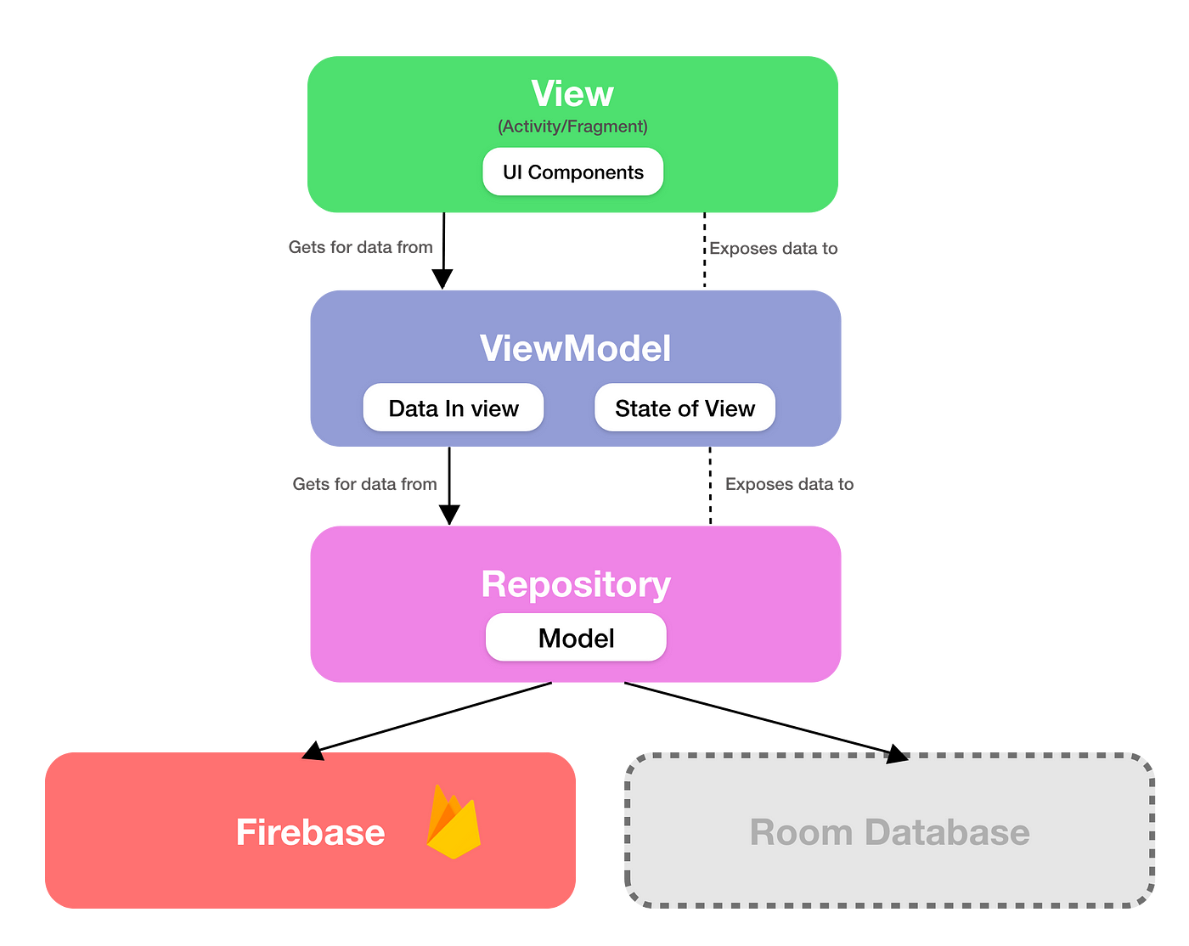

**4.1 Model-View-ViewModel (MVVM)**

Model-View-ViewModel, or MVVM, is a design pattern that helps maintain code organization and cleanliness. This pattern aids in creating manageable, testable, and maintainable apps in Flutter. It divides the application into three sections: View (the user interface), Model (the data and logic), and ViewModel (which links Model and View). This increases the code's flexibility and ease of use, particularly in collaborative projects.

**4.1.1 Model**

The data for your app is kept in the Model. To store and handle this data, you can make a Dart class in Flutter.

**4.1.2 View**

What the user sees on the screen is called the View. Widgets that show the data supplied by the ViewModel are used in Flutter.

**4.1.3 ViewModel**

The View and the Model are connected via the ViewModel. It manages user actions and the logic of the application. It is written in Flutter as a Dart class that prepares data for the View and controls the state of the application.

**________________________­______**